**Configuration files and binaries walkthrough:**

* Below is the folder structure of tomcat.

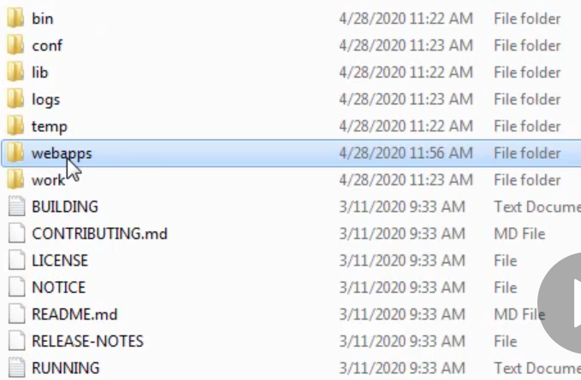

* **“bin”** directory is for all the executable like start-up and shutdown scripts for all the servers
* There is no separate installation for windows or Linux. We need to execute the start-up script from bin directory based on the server.
* The jar files which are in “bin” directory gets loaded as part of the bootstrap process. All the bootstrap classed are loaded from the bin directory.
* **“conf”** file contains the files related to configuration. The configuration related to server, users, logging, property files & context etc.
* **“Tomcat-users.xml”** file contains the user details. We can add user and assign roles here
* **In conf folder, we can add the below lines in Catalina.properties so that the tomcat can read libraries and properties from the given location.**

**common.loader="${catalina.base}/lib","${catalina.base}/lib/*.jar","${catalina.home}/lib","${catalina.home}/lib/*.jar","/opt/dependencies/lib/*.jar","/opt/dependencies/properties"**

the redirect port “8443” in server.xml is for SSL

* **“lib”** is like a shared directory. The jar files placed here can be accessible to all the applications deployed in tomcat. There will be some default jar files inside lib directory.
* Let’s say we need **“mysql.jar”** file for DB connectivity for the application we deployed in tomcat. Then we can place that jar file inside lib directory, so that the applications can access it.
* **“logs”** folder contains all the logs generated by tomcat.
* **“temp”** directory contains the temporary files. Let’s say someone is uploading or downloading a file in application, so the streaming data which required a secondary storage until it gets processed, then this temp directory will be used.
* **“webapps”** is the directory where we deploy the applications.
* Then we have **“work”** folder. We know that JSPs are converted into servlets before providing any response. So, all the conversion happens in work directory. We can see those converted JSPs in servlet “.java” and “.class” files.
* Even if we delete **“temp”** and **“work”,** the server will work. We can delete these whenever it’s required.

**Inside conf folder:**

**“server.xml”** is used to configure the port, SSL related stuff etc.

We can add DB or redis connectivity details in **“context.xml”**

We can add the properties or libraries paths in **“catalina.properties”** file.

**“logging.properties”** file is used to modify the logging related configurations.